MINISTRY OF EDUCATION AND SCIENCE OF UKRAINE
NATIONAL TECHNICAL UNIVERSITY
“KHARKIV POLYTECHNIC INSTITUTE”
NNI KNIT (ННІ КНІТ)
REPORT
on laboratory work #4
on the discipline
“Programming. Part 1 (C)”
Executed by
Student of the group KN-925i.e (КН-925і.е)
Sıla Canbolat
Kharkiv – 2025

1. Objective
I did practice writing branching logic in C using conditional statements (if/else), selection statements (switch/case), and logical conditions to determine whether a point belongs to a shaded region.
2. Software and tools
I did use the following tools:
• OS: Linux/WSL (or any Linux distribution)
• Compiler: gcc (C language)
• Debugger: GDB
• Editor: Visual Studio Code
• Version control: Git (separate branch for each part)
3. Task 04_01 — Conditional operators (if / else)
Variant 3
Task statement: For positive integers a, b, check whether a mod b equals either of the given values c or d.
I did (algorithm)
1) I did read integers a, b, c, d from the console.
2) Afterwards, I validated the input (a > 0 and b > 0) to avoid division by zero.
3) After that, I computed the remainder r = a % b.
4) Finally, I compared r with c and d and printed YES or NO (and a ternary-operator demo).
Source code — task4_01.c
#include <stdio.h>
/*
* Lab 04_01 (Variant 3)
* Task: For positive integers a, b, check whether a mod b equals either of the given values c or d.
* Notes: no loops, no arrays, no user functions.
*/
int main(void) {
int a, b, c, d;
printf("Enter a, b, c, d (positive integers): ");
if (scanf("%d %d %d %d", &a, &b, &c, &d) != 4) {
puts("Input error");
return 1;
}
if (a <= 0 || b <= 0) {
puts("Error: a and b must be positive and b must be non-zero.");
return 2;
}
int r = a % b;
printf("a mod b = %d\n", r);
if (r == c || r == d) {
puts("YES (remainder equals c or d)");
} else {
puts("NO (remainder is different)");
}
/* Ternary operator demo (same decision) */
puts((r == c || r == d) ? "Ternary: YES" : "Ternary: NO");
return 0;
}
Build and run
gcc -Wall -Wextra -O0 -g task4_01.c -o task4_01
./task4_01
Program output (3 test cases)
Test 1
Input: 17 5 2 3
Output:
a mod b = 2
YES (remainder equals c or d)
Ternary: YES
Test 2
Input: 25 7 1 4
Output:
a mod b = 4
YES (remainder equals c or d)
Ternary: YES
Test 3
Input: 30 6 1 5
Output:
a mod b = 0
NO (remainder is different)
Ternary: NO
Debug session (GDB, 10–20 lines)
gdb ./task4_01
(gdb) break main
(gdb) run
Enter a, b, c, d (positive integers): 17 5 2 3
(gdb) next
(gdb) print a
$1 = 17
(gdb) print b
$2 = 5
(gdb) next
(gdb) print r
$3 = 2
(gdb) continue
4. Task 04_02 — Selection statements (switch / case)
Variant 3
Task statement: Traffic light. Input color code (1–red, 2–yellow, 3–green) and print the corresponding action.
I did (algorithm)
1) I did read the integer code from the console.
2) Afterwards, I used one switch statement with clear case blocks and break.
3) After that, I printed the action for each valid code.
4) Finally, I handled invalid codes with default.
Source code — task4_02.c
#include <stdio.h>
/*
* Lab 04_02 (Variant 3)
* Task: Traffic light. Input color code (1–red, 2–yellow, 3–green) and print the corresponding action.
* Notes: one switch statement, no loops, no arrays, no user functions.
*/
int main(void) {
int code;
printf("Enter traffic light code (1=red, 2=yellow, 3=green): ");
if (scanf("%d", &code) != 1) {
puts("Input error");
return 1;
}
switch (code) {
case 1:
puts("RED: STOP");
break;
case 2:
puts("YELLOW: WAIT / PREPARE");
break;
case 3:
puts("GREEN: GO");
break;
default:
puts("Error: code must be 1, 2, or 3");
return 2;
}
return 0;
}
Build and run
gcc -Wall -Wextra -O0 -g task4_02.c -o task4_02
./task4_02
Program output (3 test cases)
Test 1
Input: 1
Output:
RED: STOP
Test 2
Input: 2
Output:
YELLOW: WAIT / PREPARE
Test 3
Input: 9
Output:
Error: code must be 1, 2, or 3
Debug session (GDB, 10–20 lines)
gdb ./task4_02
(gdb) break main
(gdb) run
Enter traffic light code (1=red, 2=yellow, 3=green): 2
(gdb) next
(gdb) print code
$1 = 2
(gdb) next
(gdb) continue
5. Task 04_03 — Point in region (Variant 03)
I did determine whether a point (x, y) belongs to the shaded region defined by the picture for Variant 03.
Figure 1 — Variant 03 (shaded region).
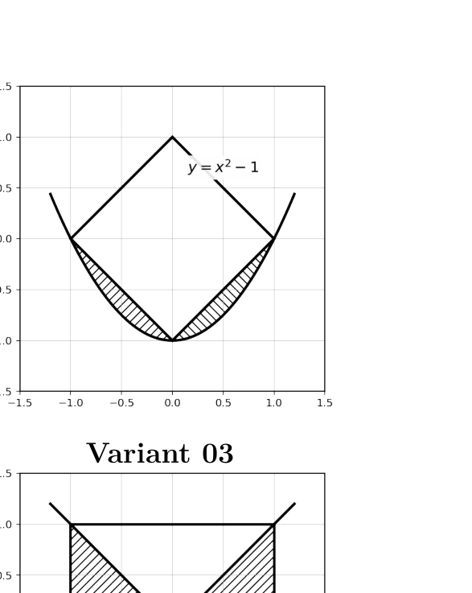
In my implementation, I used the equations shown in the picture.
Boundary equations
• Parabola: y = x^2 − 1.
• Lower diamond edges: y = |x| − 1, for −1 ≤ x ≤ 1 (two line segments).
Final logical condition (predicate)
A point (x, y) is inside the shaded region if:
• −1 ≤ x ≤ 1, and
• x^2 − 1 ≤ y ≤ |x| − 1.
I did (algorithm)
1) I did read x and y as double values.
2) Afterwards, I computed y_par = x^2 − 1 and y_v = |x| − 1.
3) After that, I checked in_x_range, above_par, and below_v using EPS.
4) Finally, I printed YES if all conditions were true, otherwise NO.
Source code — region_03.c
#include <stdio.h>
#include <stdbool.h>
#include <math.h>
/*
* Lab 04_03 (Variant 03)
* From the picture: parabola y = x^2 - 1 and a diamond with vertices (-1,0), (0,1), (1,0), (0,-1).
* The shaded region is the curved strip between:
* lower diamond edge: y = |x| - 1 (for -1 <= x <= 1)
* parabola: y = x^2 - 1
* Predicate (with EPS):
* -1 <= x <= 1 AND x^2 - 1 <= y <= |x| - 1
*/
int main(void) {
const double EPS = 1e-9;
double x, y;
printf("Enter x y: ");
if (scanf("%lf %lf", &x, &y) != 2) {
puts("Input error");
return 1;
}
double y_par = x * x - 1.0; /* y = x^2 - 1 */
double y_v = fabs(x) - 1.0; /* y = |x| - 1 */
bool in_x_range = (x >= -1.0 - EPS) && (x <= 1.0 + EPS);
bool above_par = (y >= y_par - EPS);
bool below_v = (y <= y_v + EPS);
bool inside = in_x_range && above_par && below_v;
/* Optional: print intermediate checks (useful for debugging) */
printf("y_par=%.6f, y_v=%.6f\n", y_par, y_v);
printf("in_x_range=%d, above_par=%d, below_v=%d\n",
in_x_range ? 1 : 0, above_par ? 1 : 0, below_v ? 1 : 0);
puts(inside ? "YES" : "NO");
return 0;
}
Build and run (with -lm)
gcc -Wall -Wextra -O0 -g region_03.c -lm -o region_03
./region_03
Test points (5–8) and results
1) (0.5, -0.6) -> YES
2) (-0.5, -0.6) -> YES
3) (0.5, -0.9) -> NO
4) (0.5, -0.4) -> NO
5) (1.0, 0.0) -> YES
6) (0.0, -1.0) -> YES
7) (0.0, 0.0) -> NO
Debug session (GDB, 10–20 lines)
gdb ./region_03
(gdb) break main
(gdb) run
Enter x y: 0.5 -0.6
(gdb) next
(gdb) print x
$1 = 0.5
(gdb) print y
$2 = -0.6
(gdb) next
(gdb) print y_par
$3 = -0.75
(gdb) print y_v
$4 = -0.5
(gdb) print inside
$5 = true
(gdb) continue
6. Conclusion
I did implement three separate C programs for conditional logic. Afterwards, I tested each program with multiple inputs. After that, I verified the behavior in GDB by inspecting intermediate variables and branch decisions. Finally, I prepared the report with source code, test results, and references.
7. References
1) Lab 04_01 — Conditional Statements (C). Volodymyr Savchenko, NTU “KhPI”, 2025/26.
2) Lab 04_02 — switch...case Structures (C). Volodymyr Savchenko, NTU “KhPI”, 2025/26.
3) Lab 04_03 — Point-in-Region Tests (C). Volodymyr Savchenko, NTU “KhPI”, 2025/26.
4) GCC documentation: https://gcc.gnu.org/
5) GDB documentation: https://sourceware.org/gdb/

